**Question 1**

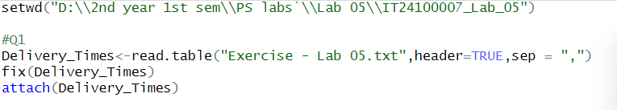

**Question 02**

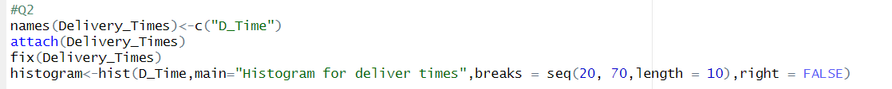

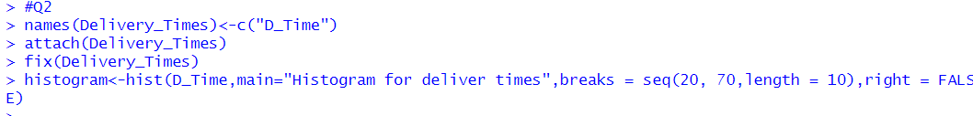

**Question 03**

* Answer - Most of the data is at the low end, forming a peak on the left, and a few high values stretch the graph out to the right.

**Question 4**



